# Midpoint

## Hash table main points

1. how to find the bucket location in the bucket array

calculate the hash of a city or a name, then mod the hash by buckets size.

1. how to address collision

When the bucket list is not empty, add the new node into the head of the list.

Before adding:

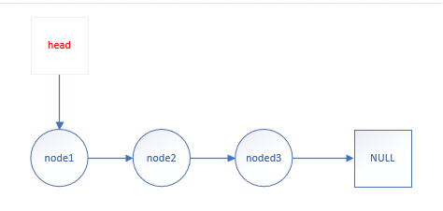

After adding:

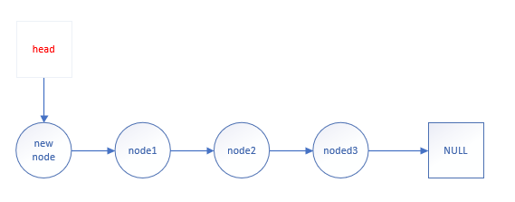

If the list is empty, make the new node as the head node directly.

1. how to search in a bucket list

use the following pattern:

n = list head

while n is not empty:

if n is the node to be searched

return n

n = n.next

The function “print_population” will also use the similar loop traversing pattern.

1. how to load table
2. read every line in csv file
3. parse them as city/state/pop
4. find the bucket location where they are inserted
5. if the information(city/state/pop) has already existed, stop the adding
6. add it to the front of the bucket list. Do not forget to update the header pointer in the bucket array.

You should make some necessary error check here.

1. how to free table

for list in buckets:

free every node in the list

free buckets